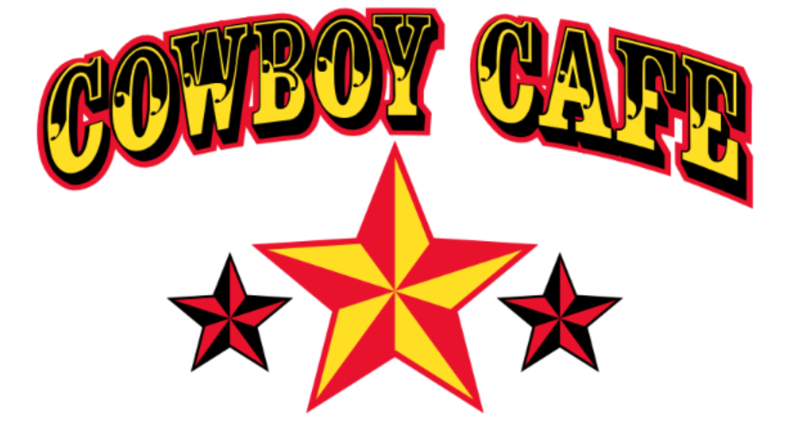

Restaurant Week Menu - $20
No Substitutions or additions to items on this menu

Course 1
Choice of Any Appetizer*/Cup of Soup/Side Salad
Cowboy favorite Apps – Edgar Wings, Fried Pickles, Jalapeño Poppers & Tater Tots
*Excludes Nacho Mountain and Sampler Platter

Course 2
tacos
OR
Pick any Sandwich
Cowboy Favorites - Buffalo Chicken Sandwich & The Cheese Steak
OR
Pick any Burger**
Cowboy Favorites – The California, The Chiliburger & The Duke
**Excludes the Barnyard Burger

Course 3
Churro Donuts — Two Churro Donuts with chocolate, Caramel, and whipped cream

