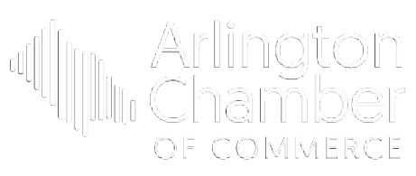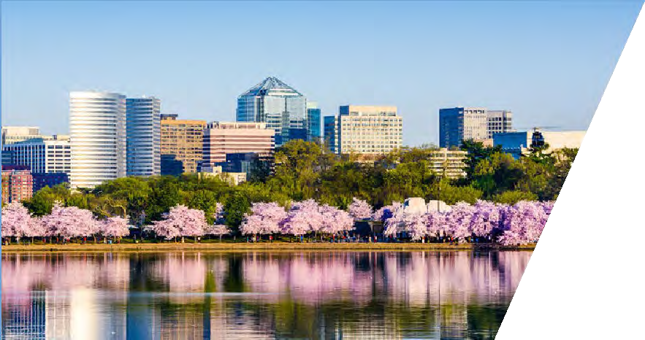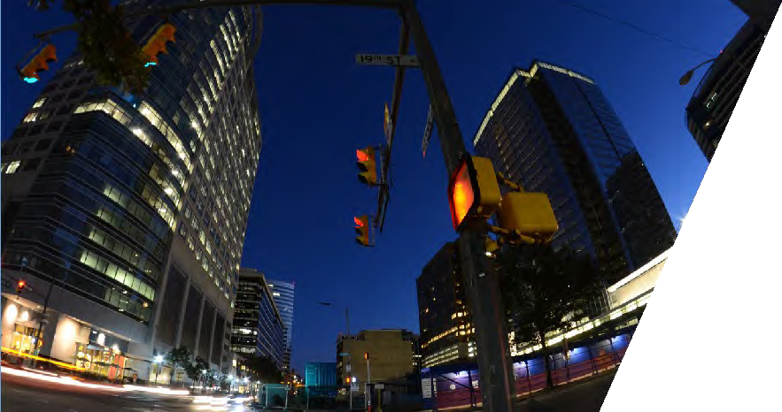

Contents

Annual Corporate Sponsor 1

Arlington Business Gala 2

Hospitality Awards 6

Arlington Chamber Volunteer Day 8

Best Business Awards 9

State of the County & Public Safety Awards 12

Arlington Restaurant Week 15

Annual Meeting 16

Breakfast Connection 19

Residential Real Estate-Focused Breakfast Connection 20

Nonprofit-Focused Breakfast Connection 21

Small Business Roundtable 22

Chamber 101 23

Nonprofit Forum 24

County Board Candidate Forum 25

Northern Virginia Elected Leaders Summit 27

Legislative Breakfast 28

Women in Business Networking Series 30

Female Founders Roundtable Series 31

COVID-19 Webinars 32

Sponsorship Contract 33



# Annual Corporate Sponsor

The Annual Corporate Sponsorship is limited to one company per vertical market. This sponsorship offers the maximum visibility and prestige for our members. It shows a true commitment to the Arlington Chamber of Commerce and its mission, serving Arlington businesses throughout the entire calendar year.

**Date:** January – December 2021

**Contact:** Andrea Aiello, Membership Engagement Manager, at [aaiello@arlingtonchamber.org](mailto:aaiello@arlingtonchamber.org) or (703) 525-2400

**Annual Corporate Sponsor at $6,750** – *One Sponsorship available per vertical market*

**Benefits:**

* Company’s logo included in scrolling banner on Chamber website homepage
* Company's logo listed on Chamber’s letterhead
* Company's logo prominently displayed in Chamber’s boardroom
* Company's logo on printed and digital Annual Corporate Sponsorship signage displayed at all Chamber events and meetings
* Company's logo listed in the bimonthly printed and digital newsletter, the *Arlingtonian*, and the weekly e-newsletter
* Chamber Annual Corporate Sponsor logo provided for you to display on your company website
* Special name badge for primary company representative to wear at in-person Chamber events
* Half-page ad in the Annual Report publication
* One set of mailing labels for all member businesses in the Chamber database
* Free attendance at Business After Business or virtual Breakfast Connection events in 2021
* Opportunity to display company brochures/material in the Chamber’s lobby
* Twice yearly exclusive Annual Corporate Sponsor receptions



# Arlington Business Gala

The Arlington Business Gala, “Arlington’s Best Night Out,” has been the Chamber’s biggest event for more than 90 years. This event is a celebration of business in Arlington, and serves as the Chamber's largest fundraiser, helping us continue our mission of strengthening businesses and the economic environment for those who work, live, and do business in Arlington. Join us for a spectacular silent auction, dinner, dancing, premium networking, and fun.

**Date:** TBA

**Location:** TBA

**Projected Attendance:** 350+

**Contact:** Andrea Aiello, Membership Engagement Manager, at [aaiello@arlingtonchamber.org](mailto:aaiello@arlingtonchamber.org) or (703) 525-2400

**Grand Sponsor** – *Classic Cottages, LLC has first right of renewal*

**Benefits:**

* Company's logo featured with top billing on printed materials, including invitation, program, event signage, and the *Arlingtonian*
* Company's logo featured with top billing in digital materials, including invitation, e- newsletter, the *Arlingtonian,* and on the Chamber's website
* Opportunity for company representative to give welcome remarks and introduce Board Chair
* Company's logo displayed on all sponsored tables
* Invitation to VIP reception
* Opportunity to request VIP guests for table
* One reserved table for (10) in a preferred location with company name displayed on table

**Step & Repeat Sponsor at $6,000** - *Exclusive Opportunity*

**Benefits:**

* Company's logo featured on printed materials, including invitation, program, event signage, and the *Arlingtonian*
* Company's logo featured in digital materials, including invitation, the *Arlingtonian*, and on the Chamber's website
* Company’s logo on sign displayed next to Step & Repeat
* Invitation to VIP Reception
* Opportunity to request VIP guests for table
* One reserved table for (10) in a preferred location with company name displayed on table



**Entertainment Sponsor** - *George Mason University has first right of renewal*

**Benefits:**

* Company's logo featured on printed materials, including invitation, program, event signage, and the *Arlingtonian*
* Company's logo featured in digital materials, including invitation, the *Arlingtonian*, and on the Chamber's website
* Company’s logo on sign displayed on stage with the band
* Invitation to VIP Reception
* Opportunity to request VIP guests for table
* One reserved table for (10) in a preferred location with company name displayed on table

**Photo Booth Sponsor** *- VIDA Fitness has first right of renewal*

**Benefits:**

* Company's logo featured on printed materials, including invitation, program, event signage, and the *Arlingtonian*
* Company's logo featured in digital materials, including invitation, the *Arlingtonian*, and on the Chamber's website
* Company's logo featured on exclusive sign displayed at photo booth
* Invitation to VIP Reception
* Seating for (4) in a preferred location

**VIP Reception Sponsor** – *Transurban has first right of renewal*

**Benefits:**

* Company's logo featured on printed materials, including invitation, program, event signage, and the *Arlingtonian*
* Company s logo featured in digital materials, including invitation, *Arlingtonian*, and on the Chamber's website
* Company's logo featured on exclusive VIP Reception sign
* Invitation to VIP Reception
* Opportunity to request VIP guests for company table
* One reserved table for (10) in a preferred location with company name displayed on table



**Beverage Sponsor** – *Washington Workplace has first right of renewal*

**Benefits:**

* Company's logo featured on printed materials, including invitation, program, event signage, and the *Arlingtonian*
* Company's logo featured in digital materials, including invitation, *Arlingtonian*, and on the Chamber's website
* Company's logo featured on exclusive signage near both bars
* Opportunity to bring cocktail napkins with company logo (company to provide napkins)
* Invitation to VIP Reception
* Opportunity to request VIP guests for company table
* One reserved table for (10) in a preferred location with company name displayed on table

**Live Auction Sponsor** – *YHB CPAs & Consultants has first right of renewal*

**Benefits:**

* Company's logo featured on printed materials, including invitation, program, event signage, and the *Arlingtonian*
* Company's logo featured in digital materials, including invitation, *Arlingtonian*, and on the Chamber's website
* Company’s logo displayed on the live auction bid paddles available at every seat at the event
* Invitation to VIP Reception
* Opportunity to request VIP guests for company table
* One reserved table for (10) in a preferred location with company name displayed on table

**Gift Sponsor at $2,800** – *Exclusive opportunity*

**Benefits:**

* Company's logo featured on printed materials, including invitation, program, event signage, and the *Arlingtonian*
* Company's logo featured in digital materials, including invitation, *Arlingtonian*, and on the Chamber's website
* Opportunity to provide a Chamber- approved gift with Company's name packaged for guests to take home
* Invitation to VIP Reception
* Seating for (4) in a preferred location



**Premier Sponsors at $2,800** – *Multiple Premier Sponsorships are available*

**Benefits:**

* Company's name featured on printed materials, including invitation, program, event signage, and the *Arlingtonian*
* Company's name featured in digital materials, including invitation, *Arlingtonian*,and on the Chamber's website
* Invitation to VIP Reception
* Opportunity to request VIP guests for company table
* One reserved table for (10) in a preferred location with company name displayed on table

**Silent Auction Sponsor at $2,250** – *Exclusive Opportunity*

**Benefits:**

* Company's logo featured on printed materials, including invitation, program, event signage, and the *Arlingtonian*
* Company's logo featured in digital materials, including invitation, *Arlingtonian*, and on the Chamber's website
* Company's logo featured on sign in silent auction area
* Invitation to VIP Reception
* Seating for (4) in a preferred location

**Benefactor Sponsors at $1,750** – *Multiple Benefactor Sponsorships are available*

**Benefits:**

* Company's name featured on printed materials, including invitation, program, event signage, and the *Arlingtonian*
* Company's name featured in digital materials, including invitation, *Arlingtonian*, and on the Chamber's website
* Invitation to VIP Reception
* Seating for (6) in a preferred location

**Patron Sponsors at $600** – *Multiple Patron Sponsorships are available*

**Benefits:**

* Company's name featured on printed materials, including invitation, program, event signage, and the *Arlingtonian*
* Company's name featured in digital materials, including invitation, the *Arlingtonian*, and on the Chamber's website
* Invitation to VIP Reception
* Seating for (2) in a preferred location

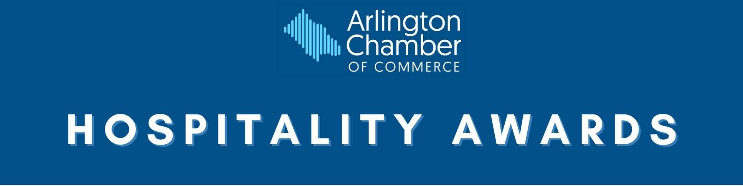

# Hospitality Awards

Celebrate the outstanding service commitment of the valuable employees who make Arlington the top destination for tourism in Virginia. The Hospitality Awards are open to Chamber members in the entire hospitality industry, including restaurants, tourist attractions, transportation companies, and hotels.

**Date:** January 2021

**Location:** TBA

**Contact:** Andrea Aiello, Membership Engagement Manager, at [aaiello@arlingtonchamber.org](mailto:aaiello@arlingtonchamber.org) or (703) 525-2400

**Grand Sponsor at $2,500** – *Exclusive opportunity*

**Benefits:**

* Company's logo featured with top billing on printed materials, including program, event signage, and the *Arlingtonian*
* Company's logo featured with top billing in digital materials, including invitation, e-newsletter, the *Arlingtonian*, and on the Chamber's website
* Opportunity for company representative to give brief remarks
* Company's logo displayed on all sponsored tables
* Opportunity for marketing display table near registration
* One reserved table for (10) in a preferred location with company name displayed on table

**Coffee Reception Sponsor** – *Arlington Economic Development has first right of renewal*

**Benefits:**

* Company's name featured on printed materials, including program, event signage, and the *Arlingtonian*
* Company's name featured in digital materials, including invitation, the *Arlingtonian*, and on the Chamber's website
* Opportunity to place promotional material or attendee gifts at every placesetting
* One reserved table for (10) in a preferred location with company name displayed on table



**Award Sponsors at $1,000** – *Multiple Award Sponsorships are available*

**Benefits:**

* Company's name featured on printed materials, including program, event signage, and the *Arlingtonian*
* Company's name featured in digital materials, including invitation, the *Arlingtonian*, and on the Chamber's website
* One reserved table for (10) in a preferred location with company name displayed on table Opportunity for company to be recognized during ceremony

**Premier Sponsors at $600** – *Multiple Premier Sponsorships are available*

**Benefits:**

* Company's name featured on printed materials, including program, event signage, and the *Arlingtonian*
* Company's name featured in digital materials, including invitation, the *Arlingtonian*, and on the Chamber's website
* One reserved table for (10) in a preferred location with company name displayed on table

**Benefactor Sponsors at $450** – *Multiple Patron Sponsorships are available*

**Benefits:**

* Company's name featured on printed materials, including program, event signage, and the *Arlingtonian*
* Company's name featured in digital materials, including invitation, the *Arlingtonian*, and on the Chamber's website
* Seating for (6) in a preferred location

**Patron Sponsors at $275** – *Multiple Patron Sponsorships are available*

**Benefits:**

* Company's name featured on printed materials, including program, event signage, and the *Arlingtonian*
* Company's name featured in digital materials, including invitation, the *Arlingtonian*, and on the Chamber's website
* Seating for (2) in a preferred location

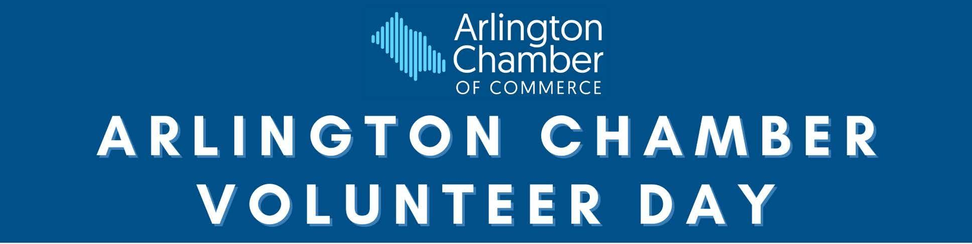

# Arlington Chamber Volunteer Day

Coordinated by the Chamber’s Community Action Committee, Arlington Chamber Volunteer Day connects businesses with nonprofit organizations for an afternoon of volunteering and team building. Nonprofits gain value through volunteer activity, as well as the partnerships that are formed between the businesses and nonprofits.

**Date:** April 2021

**Location:** Projects - various sites

**Projected Attendance:** 200+ volunteers

**Contact:** Andrea Aiello, Membership Engagement Manager, at [aaiello@arlingtonchamber.org](mailto:aaiello@arlingtonchamber.org) or (703) 525-2400

**Grand Sponsors at $3,500** – *Two Grand Sponsorships available; VIDA Fitness has first right of renewal for one; One Grand Sponsorship still available*

**Benefits:**

* Company's logo featured with top billing on printed materials, including event signage and the *Arlingtonian*
* Company's logo featured with top billing in digital materials, including invitation, e-newsletter, the *Arlingtonian*, and on the Chamber's website
* Company's logo featured on event t-shirts
* Opportunity for company representative to give remarks during event kickoff

**Premier Sponsors at $1,000** – *Multiple Premier Sponsorships are available*

**Benefits:**

* Company's logo featured on printed materials, including event signage and the *Arlingtonian*
* Company's logo featured in digital materials, including invitation, the *Arlingtonian*, and on the Chamber's website
* Company's logo featured on event t-shirts

**Patron Sponsors at $300** – *Multiple Patron Sponsorships are available*

**Benefits:**

* Company's name featured on printed materials, including event signage and the *Arlingtonian*
* Company's name featured in digital materials, including invitation, the *Arlingtonian*, and on the Chamber's website
* Company's name listed on event t-shirts

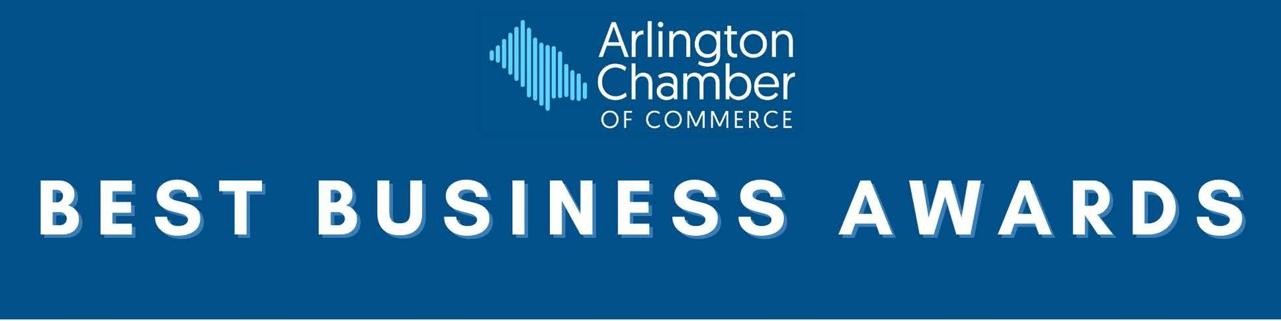

# 

# Best Business Awards

For over 30 years, the Arlington Chamber of Commerce has recognized outstanding businesses in the community with the prestigious Arlington Best Business Awards. This merit- based honor is presented to businesses that deliver exceptional quality of service to their customers, are industry leaders or offer a unique approach to delivery of its goods or services, and display an interest in and concern for the Arlington community. This distinguished evening event consistently has a sold-out crowd of members of Arlington’s finest businesses and celebrates all of the business success in the Arlington community.

**Date:** TBA

**Location:** TBA

**Projected Attendance:** 200+

**Contact:** Andrea Aiello, Membership Engagement Manager, at [aaiello@arlingtonchamber.org](mailto:aaiello@arlingtonchamber.org) or (703) 525-2400

**Grand Sponsor** – *VIDA Fitness has first right of renewal*

**Benefits:**

* Company's logo featured with top billing on printed materials, including program, event signage, and the *Arlingtonian*
* Company's logo featured with top billing in digital materials, including invitation, e-newsletter, the *Arlingtonian*, and on the Chamber's website
* Opportunity for display table near registration
* Opportunity for company representative to provide brief remarks
* Company's logo displayed on all sponsored tables
* Opportunity to request VIP guests for company table
* One reserved table for (10) in a preferred location with company name displayed on table

**Hall of Fame Sponsor at $2,000 -** *Exclusive opportunity*

**Benefits:**

* Company's name featured on printed materials, including program, event signage, and the *Arlingtonian*
* Company's name featured in digital materials, including invitation, the *Arlingtonian*, and on the Chamber's website
* Opportunity to host current and/or past Hall of Fame inductees at the table
* Company recognized during induction of new Hall of Fame inductees
* Opportunity to request VIP guests for company table
* One reserved table for (10) in a preferred location with company name on table



**Award Sponsors at $1,750** – *The following Award Sponsorships are available:*

* **Home-Based Business Award** *- Northwest Federal Credit Union has first right of renewal*
* **Service Award** *– Exclusive opportunity*
* **Retail Award** *- John Marshall Bank has first right of renewal*
* **Technology Award** – *Arlington Economic Development has first right of renewal*
* **Nonprofit Award** – *Arlington Community Federal Credit Union has first right of renewal*
* **Sustainability Award –** *Exclusive opportunity*

**Benefits:**

* Company's name featured on printed materials, including program, event signage, and the *Arlingtonian*
* Company's name featured in digital materials, including invitation, the *Arlingtonian*, and on the Chamber's website
* Opportunity for company to be recognized during presentation of award at ceremony
* Company name printed on the award plaque
* Opportunity to request VIP guests for company table
* One reserved table for (10) in a preferred location with company name displayed on table

**Premier Sponsors at $1,500** – *Multiple Premier Sponsorships are available*

**Benefits:**

* Company's name featured on printed materials, including program, event signage, and the *Arlingtonian*
* Company's name featured in digital materials, including invitation, the *Arlingtonian*, and on the Chamber's website
* Opportunity to request VIP guests for company table
* One reserved table for (10) in a preferred location with company name displayed on table

**Benefactor Sponsors at $850** – *Multiple Benefactor Sponsorships are available*

**Benefits:**

* Company's name featured on printed materials, including program, event signage, and the *Arlingtonian*
* Company's name featured in digital materials, including invitation, the *Arlingtonian*, and on the Chamber's website
* Seating for (6) in a preferred location



**Patron Sponsors at $375** – *Multiple Patron Sponsorships are available*

**Benefits:**

* Company's name featured on printed materials, including program, event signage, and the *Arlingtonian*
* Company's name featured in digital materials, including invitation, the *Arlingtonian*, and on the Chamber's website

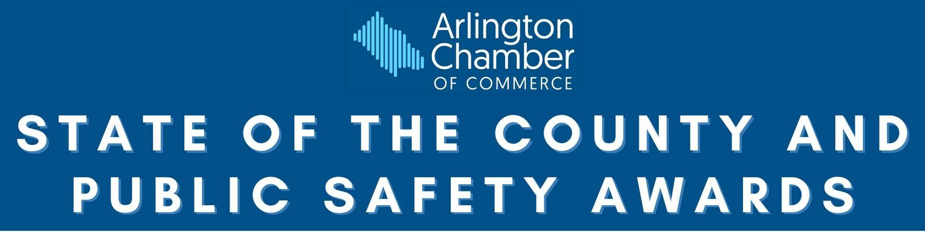

# State of the County & Public Safety Awards

The State of the County & Public Safety Awards is a breakfast event that celebrates Arlington and the individuals that make our community an outstanding place to live and work. This event includes an address by the Chair of the Arlington County Board, who will highlight the economic and development status of Arlington. The event will also feature an awards ceremony to honor public safety personnel and first responders from Arlington County’s Fire Department, Police Department, Department of Public Safety Communications & Emergency Management, and Office of the Sheriff, who have exemplified extraordinary heroic actions and performance of their duties.

**Date:** June 2021

**Location:** TBA

**Projected Attendance:** 200+

**Contact:** Andrea Aiello, Membership Engagement Manager, at [aaiello@arlingtonchamber.org](mailto:aaiello@arlingtonchamber.org) or (703) 525-2400

**Grand Sponsor** – *Virginia Hospital Center has first right of renewal*

**Benefits:**

* Company's logo featured with top billing on printed materials, including program, event signage, and the *Arlingtonian*
* Company's logo featured with top billing in digital materials, including invitation, e-newsletter, the *Arlingtonian*, and on the Chamber's website
* Opportunity for a company representative to make welcome remarks
* Opportunity for marketing display table near registration
* Company's logo displayed on all sponsored tables
* One reserved table for (8) in a preferred location with company name displayed on table (two additional seats will be filled by award winners/VIP guests)

**Keynote Sponsor** – *Dominion Energy has first right of renewal*

**Benefits:**

* Company's logo featured on printed materials, including program, event signage, and the *Arlingtonian*
* Company's logo featured in digital materials, including invitation, the *Arlingtonian*, and on the Chamber's website
* Opportunity to introduce the Keynote speaker, Chair of the Arlington County Board
* Opportunity for a display table for promotional materials
* Opportunity to request VIP guests for company table
* One reserved table for (8) in a preferred location with company name displayed on table (two additional seats will be filled by award winners/VIP guests)



**Award Sponsors** (two available) – *AT&T and Arlington Community Federal Credit Union have first right of renewal*

**Benefits:**

* Company's logo featured on printed materials, including program, event signage, and the *Arlingtonian*
* Company's logo featured in digital materials, including invitation, the *Arlingtonian*, and on the Chamber's website
* Company verbally recognized during event
* One reserved table for (8) in a preferred location with company name displayed on table (two additional seats will be filled by award winners/VIP guests)

**Community Champion Sponsor at $1,500** – *Exclusive opportunity*

**Benefits:**

* Company's logo featured on printed materials, including program, event signage, and the *Arlingtonian*
* Company's logo featured in digital materials, including invitation, the *Arlingtonian*, and on the Chamber's website
* Opportunity for a display table for promotional materials
* Seating for (4) in a preferred location

**Premier Sponsors at $700** – *Multiple Premier Sponsorships are available*

**Benefits:**

* Company's name featured on printed materials, including program, event signage, and the *Arlingtonian*
* Company's name featured in digital materials, including invitation, the *Arlingtonian*, and on the Chamber's website
* One reserved table for (8) in a preferred location with company name displayed on table (two additional seats will be filled by award winners/VIP guests)



**Benefactor Sponsors at $500** – *Multiple Benefactor Sponsorships are available*

**Benefits:**

* Company's name featured in printed materials, including program, event signage, and the *Arlingtonian*
* Company's name featured in digital materials, including invitation, the *Arlingtonian*, and on the Chamber's website
* Seating for (6) in a preferred location

**Patron Sponsors at $300** – *Multiple Patron Sponsorships are available*

**Benefits:**

* Company's name featured on printed materials, including program, event signage, and the *Arlingtonian*
* Company's name featured in digital materials, including invitation, the *Arlingtonian*, and on the Chamber's website
* Seating for (2) in a preferred location



# Arlington Restaurant Week

The Arlington Chamber of Commerce is proud to host the 2nd annual Arlington Restaurant Week! For one week in October Arlington restaurants will gain exposure through extensive media promotion to attract new and repeat patrons. Arlington Restaurant Week is open to all restaurants from fast-casual to five-star with a flexible price point structure to accommodate the diversity of the local restaurant scene.

**Dates:** October 2021

**Contact:** Olivia McKay, *Operations Coordinator*, [chamber@arlingtonchamber.org](mailto:chamber@arlingtonchamber.org) or (703) 525-2400

**Presenting Sponsor** – *Filled by Amazon*

**Benefits:**

* Company’s logo featured with top billing in all marketing materials and exclusively featured in Arlington Restaurant Week logo
* Company’s logo featured with top billing in the *Arlingtonian* print edition
* Company’s logo featured with top billing in digital materials, including e-newsletter, the *Arlingtonian*, and on the Chamber’s website
* Allows for all Arlington Chamber restaurants to forego paying registration fee to participate (approximately 60 restaurants were eligible to participate in 2020)
* Four dedicated social media posts

**Premier Sponsors at $5,000** – *Multiple Premier Sponsorships are available*

**Benefits:**

* Company’s logo featured in digital materials, including the *Arlingtonian* and on the Chamber’s website
* Three social media posts

**Restaurant Champion at $1,000** – *Multiple Restaurant Champion sponsorships available*

**Benefits:**

* Company’s name featured in digital materials, including the *Arlingtonian* and on the Chamber’s website
* Three social media posts

**Restaurant Supporter at $500** – *Multiple Restaurant Supporter sponsorships available*

**Benefits:**

* Company name featured in digital materials, including the *Arlingtonian* and on the Chamber’s website



# Annual Meeting

The Annual Meeting celebrates the year in review for Arlington through the eyes of the Arlington Chamber of Commerce. This luncheon celebration features three awards and an elite guest speaker. Past speakers include Senator Mark Warner, Chuck Todd, Ted Leonsis, and Aneesh Chopra. This is a key event for business and community leaders giving them the opportunity to build relationships with other professionals from across the area.

**Date:** December 2021

**Location:** TBA

**Projected Attendance:** 250+

**Contact:** Andrea Aiello, Membership Engagement Manager, at [aaiello@arlingtonchamber.org](mailto:aaiello@arlingtonchamber.org) or (703) 525-2400

**Grand Sponsor** – *Comcast has first right of renewal*

**Benefits:**

* Company's logo featured with top billing on printed materials, including program, event signage, and the *Arlingtonian*
* Company's logo featured with top billing in digital materials, including invitation, e-newsletter, the *Arlingtonian*, and on the Chamber's website
* Opportunity for company representative to introduce keynote speaker
* Invitation to VIP reception
* Company logo displayed on all sponsored tables
* Opportunity to request VIP guests for company table
* One reserved table for (10) in a preferred location with company name displayed on table

**Community Champion Sponsor at $2,000** – *Multiple Community Champion Sponsorships available*

**Benefits:**

* Company's logo featured on printed materials, including program, event signage, and the *Arlingtonian*
* Company's logo featured in digital materials, including invitation, the *Arlingtonian*, and on the Chamber's website
* Invitation to VIP reception
* Opportunity to request VIP guests for company table
* One reserved table for (10) in a preferred location with company name displayed on table



**Award Sponsors at $1,500** – *The following Award Sponsorships are available:*

* **President’s Award** – *Transurban has first right of renewal*
* **Committee of the Year Award** – *Walsh, Colucci, Lubeley & Walsh has first right of renewal*
* **Chair's Award** – *Rosslyn Business Improvement District has first right of rewewal*

**Benefits:**

* Company's name featured on printed materials, including program, event signage, and the *Arlingtonian*
* Company's name featured in digital materials, including invitation, the *Arlingtonian*, and on the Chamber's website
* Company name printed on the award plaque
* Company verbally recognized during presentation of award at ceremony
* Invitation to VIP reception
* Opportunity to request VIP guests for company table
* One table for (10) at event in a preferred location with company name displayed on table

**Community Supporter Sponsor at $1,000** – *Multiple Community Supporter Sponsorships available*

**Benefits:**

* Company's name featured on printed materials, including program, event signage, and the *Arlingtonian*
* Company's name featured in digital materials, including invitation, the *Arlingtonian*, webinar slide, and on the Chamber's website
* Invitation to VIP reception
* Opportunity to request VIP guests for company table
* One reserved table for (10) in a preferred location with company name displayed on table



**Premier Sponsors at $800** – *Multiple Premier Sponsorships are available*

**Benefits:**

* Company's name featured on printed materials, including program, event signage, and the *Arlingtonian*
* Company's name featured in digital materials, including invitation, the *Arlingtonian*, and on the Chamber's website
* Opportunity to request VIP guests for company table
* One reserved table for (10) in a preferred location with company name displayed on table

**Benefactor Sponsors at $550** – *Multiple Benefactor Sponsorships are available*

**Benefits:**

* Company's name featured on printed materials, including program, event signage, and the *Arlingtonian*
* Company's name featured in digital materials, including invitation, the *Arlingtonian*, and on the Chamber's website
* Seating for (6) in a preferred location

**Patron Sponsors at $300** – *Multiple Patron Sponsorships are available*

**Benefits:**

* Company's name featured on printed materials, including program, event signage, and the *Arlingtonian*
* Company's name featured in digital materials, including invitation, the *Arlingtonian*, and on the Chamber's website
* Seating for (2) in a preferred location

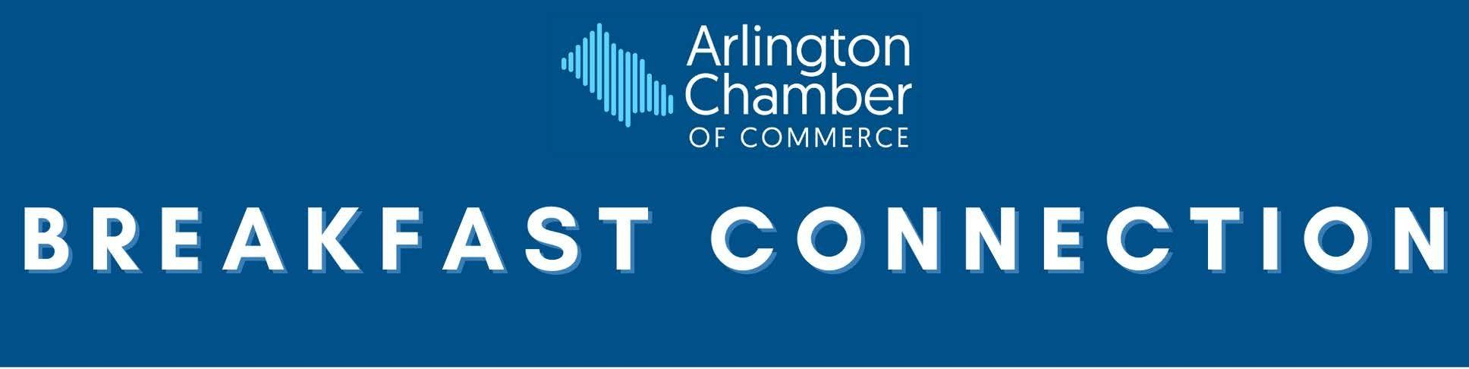

# Breakfast Connection

The dynamic format of the Breakfast Connection gives the attendees a chance to bring their business to the table. The event focuses on networking and provides attendees the chance to exchange business cards, develop new prospects, and share a 60-second elevator pitch with each table. The event focuses on roundtable power networking and gives guests the chance to meet many people before the work day begins. In order to broaden or target your reach, some of the events will be co-marketed with a partner organization or pertain to a specific topic.

**Date**: 10 events per year in 2021

**Location**: TBA

**Projected Attendance:** 50 – 70 per event

**Contact:** Andrea Aiello, Membership Engagement Manager, at [aaiello@arlingtonchamber.org](mailto:aaiello@arlingtonchamber.org) or (703) 525-2400

**Grand Sponsor** – *State Department Federal Credit Union has first right of renewal*

**Benefits:**

* Company's logo featured with top billing on printed materials, including event signage and the *Arlingtonian*
* Company's logo featured with top billing in digital materials, including invitation, e-newsletter, the *Arlingtonian*, and on the Chamber's website
* Opportunity to give 60-second elevator pitch during program
* Special name badge for representative(s) highlighting sponsor designation
* Opportunity to give away promotional items at every place setting at each event or at a display table at every event
* Seating for (2) at every event

**Premier Sponsor at $1000** – *Exclusive opportunity (must be different industry than Grand Sponsor)*

**Benefits:**

* Company's name featured on printed materials, including event signage and the *Arlingtonian*
* Company's name featured in digital materials, including invitation, the *Arlingtonian*, and on the Chamber's website
* Special name badge for representative(s) highlighting sponsor designation
* Opportunity to give away promotional items at every place setting at each event
* Seating for (2) at every event

**Supporting Sponsors at $750** - *Multiple Supporting Sponsorships available*

**Benefits:**

* Company's name featured in printed and digital materials, including invitation, the *Arlingtonian*, and on the Chamber's website
* Business card size ad on handout for all attendees
* Seating for (2) at three consecutive events



# Residential Real Estate-Focused Breakfast Connection

If you're looking to meet real estate agents, mortgage bankers, insurance agents, or title companies, then our Residential Real Estate-Focused Breakfast Connection is the perfect event for you. This special event focuses on power networking so that guests can increase their connections within the residential real estate space, all before the workday even begins. Attendees will have the opportunity to exchange business cards, develop new prospects, and share a 60-second pitch with each table. **Industry Sponsor is for a single event.**

**Date:** Spring and Fall 2021

**Location:** TBA

**Contact:** Andrea Aiello, Membership Engagement Manager, at [aaiello@arlingtonchamber.org](mailto:aaiello@arlingtonchamber.org) or (703) 525-2400

**Grand Sponsor** - *State Department Federal Credit Union has first right of renewal*

**Benefits:**

* Company's logo featured with top billing on printed materials, including event signage and the *Arlingtonian*
* Company's logo featured with top billing in digital materials, including invitation, e-newsletter, the *Arlingtonian*, and on the Chamber's website
* Opportunity to give 60-second elevator pitch during program
* Special name badge for representative(s) highlighting sponsor designation
* Opportunity to give away promotional items at every place setting at each event or at a display table at every event
* Seating for (2) at every event

**Premier Sponsor at $1000** – *Exclusive opportunity*

**Benefits:**

* Company's name featured on printed materials, including event signage and the *Arlingtonian*
* Company's name featured in digital materials, including invitation, the *Arlingtonian*, and on the Chamber's website
* Special name badge for representative(s) highlighting sponsor designation
* Opportunity to give away promotional items at every place setting at each event
* Seating for (2) at every event

**Industry Sponsors at $500** - *Multiple Industry Sponsorships available*

**Benefits:**

* Company's name featured in printed and digital materials, including invitation, the *Arlingtonian*, and on the Chamber's website
* Business card size ad on handout for all attendees
* Seating for (2) at this event



# Nonprofit-Focused Breakfast Connection

This event focuses on power networking and will provide attendees the chance to share a 60- second pitch with their fellow participants. Focusing this event on nonprofits allows you to form connections to either deepen your **Corporate Social Responsibility (CSR) program**, or to explore relationships to help you get started.

**Date**: July 2021

**Location**: TBA

**Contact:** Andrea Aiello, Membership Engagement Manager, at [aaiello@arlingtonchamber.org](mailto:aaiello@arlingtonchamber.org) or (703) 525-2400

**Grand Sponsor** - *Filled by State Department Federal Credit Union*

**Benefits:**

* Company's logo featured with top billing on printed materials, including event signage and the *Arlingtonian*
* Company's logo featured with top billing in digital materials, including invitation, e-newsletter, the *Arlingtonian*, and on the Chamber's website
* Opportunity to give 60-second elevator pitch during program
* Special name badge at in-person events for representative(s) highlighting sponsor designation
* Opportunity to give away promotional items at every place setting at each event or at a display table at every event
* Seating for (2) at every event

**Premier Sponsor at $1000** – *Exclusive opportunity*

**Benefits:**

* Company's name featured on printed materials, including event signage and the *Arlingtonian*
* Company's name featured in digital materials, including invitation, the *Arlingtonian*, and on the Chamber's website
* Special name badge at in-person events for representative(s) highlighting sponsor designation
* Opportunity to give away promotional items at every place setting at each event
* Seating for (2) at every event

**Community Sponsors at $350** - *Multiple Community Sponsorships available*

**Benefits:**

* Company's name featured on printed materials, including event signage
* Company's name featured in digital materials, including invitation and on the Chamber's website
* Seating for (2) at this event



# Small Business Roundtable

The Chamber's free monthly Small Business Roundtable is an important educational and networking opportunity for small businesses. This event provides expert speakers on topics to help you grow your business, such as digital marketing and business development, and also gives you the opportunity to make connections and grow your professional network. The forum is applicable to a variety of businesses and employee levels, from front-line customer service to owners.

**Dates:** 11 lunchtime events on the last Wednesday of the month throughout 2021

**Location:** VIDA Fitness Boardroom at the Arlington Chamber

**Projected Attendance:** 20 per event

**Contact:** Andrea Aiello, Membership Engagement Manager, at [aaiello@arlingtonchamber.org](mailto:aaiello@arlingtonchamber.org) or (703) 525-2400

**Grand Sponsor** – *Filled by The* *National Capital Bank of Washington*

**Benefits:**

* Company representative recognized at every event
* Opportunity to display promotional material at every event
* Company's name featured in digital materials, including invitation, e-newsletter, the *Arlingtonian*, and on the Chamber's website



# Chamber 101

This free networking seminar is a great place for new, existing, and prospective members. Learn how to get the most out of your Chamber membership by taking advantage of the many resources the Chamber has to offer. Find out more about events, sponsorship opportunities, committees, and advocacy work, while networking with other members.

**Date:** Monthly on the first Thursday of the month throughout 2021

**Location:** VIDA Fitness Boardroom at the Arlington Chamber

**Projected Attendance:** 15 – 25 per event

**Contact:** Andrea Aiello, Membership Engagement Manager, at [aaiello@arlingtonchamber.org](mailto:aaiello@arlingtonchamber.org) or (703) 525-2400

**Grand Sponsor** – *Filled by Michael Garcia, State Farm Insurance*

**Benefits:**

* Company's logo featured with top billing on printed materials, including event signage, and the *Arlingtonian*
* Company's logo featured with top billing in digital materials, including invitation, e-newsletter, the *Arlingtonian*, and on the Chamber's website
* Company given verbal recognition at each event
* Opportunity for company representative to speak as part of the program

**Premier Sponsor –** *Filled by Monument Home Loans*

**Benefits**:

* Company given verbal recognition at each event
* Company's name featured in digital materials, including invitation, the *Arlingtonian*, and on the Chamber's website

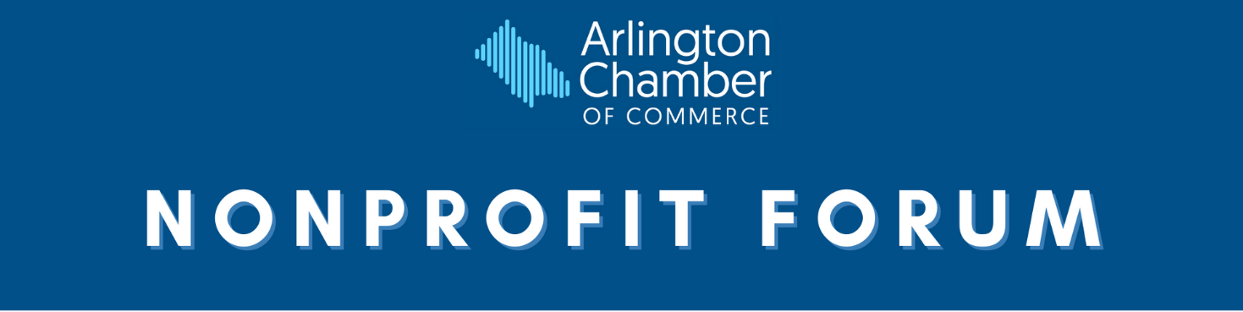

# Nonprofit Forum

Produced by the Chamber’s Community Action Committee, this series of Nonprofit Forums feature expert speakers on timely topics of relevance to the nonprofit community. Past topics include: How to Get Past the Overhead Ratio, Maximizing Impact with Online Giving Days, The Dos & Don’ts of Foundation Grant Proposals, and Planning Ahead: The How-To Guide to Setting up a Planned Giving Program. **Each sponsorship is for a single forum.**

**Date:** Winter**,** Spring, and Fall 2021

**Location:** TBA

**Contact:** Andrea Aiello, Membership Engagement Manager, at [aaiello@arlingtonchamber.org](mailto:aaiello@arlingtonchamber.org) or (703) 525-2400

**Winter Grand Sponsor** *– Filled by Sikich*

**Spring Grand Sponsor** - *Arlington Community Federal Credit Union has first right of renewal*

**Summer/Fall Grand Sponsor** *- AES has first right of renewal*

**Benefits:**

* Company's logo featured with top billing in digital materials, including invitation, e-newsletter, the *Arlingtonian*, and on the Chamber's website
* Opportunity for company representative to give brief remarks
* Seating for (4)

**Premier Sponsors at $750** – *Multiple Premier Sponsorships are available for each event*

**Benefits:**

* Company's logo featured in digital materials, including invitation, the *Arlingtonian*, and on the Chamber's website
* Seating for (2)

**Patron Sponsors at $250** – *Multiple Patron Sponsorships are available for each event*

**Benefits:**

* Company's name featured in digital materials, including invitation, the *Arlingtonian*, and on the Chamber's website
* Seating for (2)



# 

# County Board Candidate Forum

The Arlington Chamber’s business-themed candidate forum features a moderated discussion of topics important to the Arlington business community with the candidates running for seats on the Arlington County Board. The event will provide candidates the opportunity to engage with local business leaders and address the key issues affecting the business community.

**Date:** TBA

**Location:** TBA

**Contact:** Andrea Aiello, Membership Engagement Manager, at [aaiello@arlingtonchamber.org](mailto:aaiello@arlingtonchamber.org) or (703) 525-2400

**Grand Sponsor** – *George Mason University has first right of renewal*

**Benefits:**

* Company's logo featured with top billing in printed materials including program, event signage, and the *Arlingtonian*
* Company’s logo featured with top billing in digital materials, including invitation, the *Arlingtonian*, and on the Chamber's website
* Company verbally recognized at event
* Opportunity for company representative to give welcome remarks
* Reserved seating for (4) in preferred location

**Premier Sponsors at $750** – *Multiple Premier Sponsorships available*

**Benefits:**

* Company's logo featured in printed materials including program, event signage, and the *Arlingtonian*
* Company’s logo featured in digital materials, including invitation, the *Arlingtonian*, and on the Chamber's website
* Reserved seating for (4) in preferred location



**Benefactor Sponsors at $500** – *Multiple Benefactor Sponsorships are available*

**Benefits:**

* Company's name featured in printed materials including program, event signage, and the *Arlingtonian*
* Company’s name featured in digital materials, including invitation, the *Arlingtonian*, and on the Chamber's website
* Seating for (4)

**Patron Sponsors at $250** – *Multiple Patron Sponsorships are available*

**Benefits:**

* Company's name featured in printed materials including program, event signage, and the *Arlingtonian*
* Company’s name featured in digital materials, including invitation, the *Arlingtonian*, and on the Chamber's website
* Seating for (2)

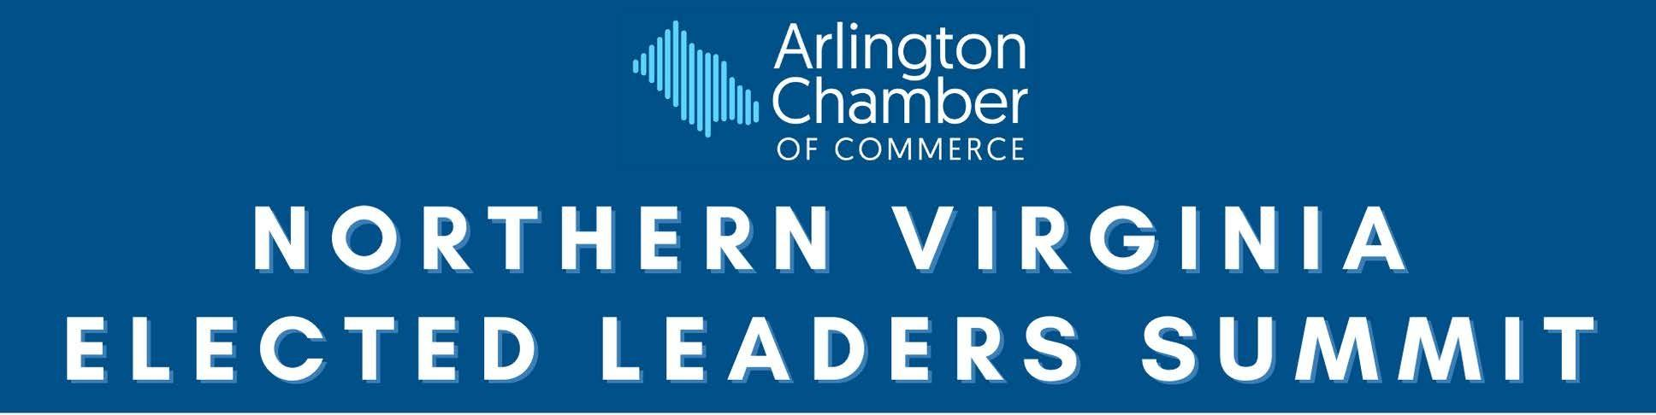

# 

# Northern Virginia Elected Leaders Summit

The Northern Virginia Elected Leaders Summit offers business leaders the opportunity to hear from the region’s elected leaders about the economic climate and offer thoughts on how each Northern Virginia jurisdiction can work together for the betterment of our regional economy.

**Date:** TBA

**Location:** TBA

**Contact:** Andrea Aiello, Membership Engagement Manager, at [aaiello@arlingtonchamber.org](mailto:aaiello@arlingtonchamber.org) or (703) 525-2400

**Grand Sponsor** – *Dominion Energy has first right of renewal*

**Benefits:**

* Company's logo featured with top billing on printed materials, including program, event signage, and the *Arlingtonian*
* Company's logo featured with top billing in digital materials, including invitation, e-newsletter, the *Arlingtonian*, and on the Chamber's website
* Company verbally recognized at event
* Opportunity for company representative to give welcome remarks
* Reserved seating for (5) in a preferred location

**Premier Sponsors at $1,000** – *Multiple Premier Sponsorships are available*

**Benefits:**

* Company's logo featured on printed materials, including program, event signage, and the *Arlingtonian*
* Company's logo featured in digital materials, including invitation, the *Arlingtonian*, and on the Chamber's website
* Reserved seating for (5) in a preferred location

**Patron Sponsors at $350** – *Multiple Patron Sponsorships are available*

**Benefits:**

* Company's name featured on printed materials, including program, event signage, and the *Arlingtonian*
* Company's name featured in digital materials, including invitation, the *Arlingtonian*, and on the Chamber's website
* Seating for (2)

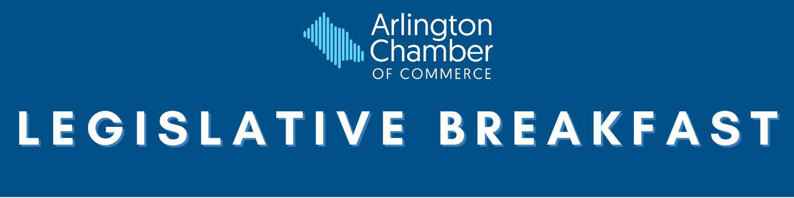

# Legislative Breakfast

The Legislative Breakfast offers Arlington’s business community the opportunity to hear about the recent General Assembly session from the legislators who represent Arlington in Richmond. Arlington’s members of the Virginia Senate and House of Delegates will discuss the legislation that they patroned, the issues that the General Assembly took up, and the outlook for Arlington and the Commonwealth of Virginia.

**Date:** TBA

**Location:** TBA

**Contact:** Andrea Aiello, Membership Engagement Manager, at [aaiello@arlingtonchamber.org](mailto:aaiello@arlingtonchamber.org) or (703) 525-2400

**Grand Sponsor at $2,500** – *Exclusive opportunity*

**Benefits:**

* Company's logo featured with top billing in event materials, including program, event slide, and the *Arlingtonian*
* Company's logo featured with top billing in digital materials, including invitation, e-newsletter, the *Arlingtonian*, and on the Chamber's website
* Opportunity for company representative to give welcome remarks
* Opportunity for (1) company representative to attend a virtual VIP reception prior to event start
* Registration for (5)

**Premier Sponsors at $1,500** – *Multiple Premier Sponsorships are available*

**Benefits:**

* Company's logo featured in event materials, including program, event slide, and the *Arlingtonian*
* Company's logo featured in digital materials, including invitation, the *Arlingtonian*, and on the Chamber's website
* Opportunity for (1) company representative to attend a virtual VIP reception prior to event start
* Registration for (5)



**Benefactor Sponsors at $1,000** – *Multiple Benefactor Sponsorships are available*

**Benefits:**

* Company's name featured in event materials, including program, event slide, and the *Arlingtonian*
* Company's name featured in digital materials, including invitation, the *Arlingtonian*, and on the Chamber's website
* Registration for (5)

**Patron Sponsors at $500** – *Multiple Patron Sponsorships are available*

**Benefits:**

* Company's name featured in event materials, including program, event slide, and the *Arlingtonian*
* Company's name featured in digital materials, including invitation, the *Arlingtonian*, and on the Chamber's website
* Registration for (2)



The programming below is built upon the success of Awesome Women (AWE), which was founded in 2014 to provide a supportive community where business women can connect. In 2020 that community evolved into a program within the Arlington Chamber of Commerce. The events below will continue the mission of AWE to educate, empower and connect women in business.

# Women in Business Networking Series

This series of networking events is open to **all women** to expand your network, share knowledge, exchange ideas, and offer advice. The events focus on networking to grow your business opportunities and support others who know what it’s like to be a woman in business.

**Dates**: 6 events per year in 2021

**Contact:** Andrea Aiello, Membership Engagement Manager, at [aaiello@arlingtonchamber.org](mailto:aaiello@arlingtonchamber.org) or (703) 525-2400

**Grand Sponsor –** *Filled by Arlington Community Federal Credit Union*

**Benefits:**

* Company's logo featured with top billing in the *Arlingtonian* print edition
* Company's logo featured with top billing in digital materials, including invitation, e-newsletter, the *Arlingtonian*, and on the Chamber's website
* Opportunity to give welcome remarks and introduce speaker, if applicable
* Registration for (2) to every event

**Premier Sponsor for the series at $1,000 -** *Multiple Premier Sponsorships available*

**Benefits:**

* Company's logo featured in the *Arlingtonian* print edition
* Company's logo featured in digital materials, including invitation, the *Arlingtonian*, and on the Chamber's website
* Registration for (2) to every event

**Patron Sponsors at $200 per event** - *Multiple Patron Sponsorships available*

**Benefits:**

* Company's name featured in digital materials, including invitation and on the Chamber's website
* Registration for (1) to an event of your choice

**Premier Sponsor of both series (12 events) at $1,800** – *Multiple Premier Sponsorships available*



# Female Founders Roundtable Series

This series of events focuses on **women business owners** and will be an open forum to discuss the challenges and successes of women who understand what it takes to own and run a business. The format will include roundtable power networking and guest speakers, and will give you tools that can help you grow and manage your business.

**Dates**: 6 events per year in 2021

**Contact**: Andrea Aiello, Membership Engagement Manager, at [aaiello@arlingtonchamber.org](mailto:aaiello@arlingtonchamber.org) or (730) 525-2400

**Grand Sponsor –** *Filled by Arlington Community Federal Credit Union*

**Benefits:**

* Company's logo featured with top billing in the *Arlingtonian* print edition
* Company's logo featured with top billing in digital materials, including invitation, e-newsletter, the *Arlingtonian*, and on the Chamber's website
* Opportunity to give welcome remarks and introduce speaker
* Registration for (2) to every event

**Premier Sponsor for the series at $1,000 -** *Multiple Premier Sponsorships available*

**Benefits:**

* Company's logo featured in the *Arlingtonian* print edition
* Company's logo featured in digital materials, including invitation, the *Arlingtonian*, and on the Chamber's website
* Registration for (2) to every event

**Patron Sponsors at $200 per event** - *Multiple Patron Sponsorships available*

**Benefits:**

* Company's name featured in digital materials, including invitation and on the Chamber's website
* Registration for (1) to an event of your choice

**Premier Sponsor of both series (12 events) at $1,800** – *Multiple Premier Sponsorships available*

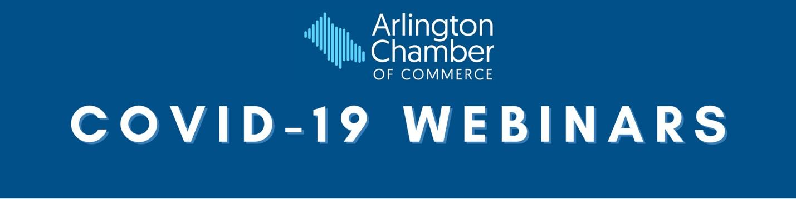

# 

# COVID-19 Webinars

This series of events focuses on some of the hardest hit industries during the COVID-19 pandemic by bringing in experts to provide tips and suggestions for reopening businesses. Past topics include: Marketing, Best Practices for Reopening, Looking Ahead on Air Travel and Its Economic Impact, and Navigating the New Commute With Flexible Workplace Policies.

All topics must be approved by the Chamber.

**Contact:** Andrea Aiello, Membership Engagement Manager, at [aaiello@arlingtonchamber.org](mailto:aaiello@arlingtonchamber.org) or (703) 525-2400

**Webinar Sponsor at $500** –*Exclusive opportunity*

**Benefits:**

* Company’s logo in digital materials, including invitation, e-newsletter, and on the Chamber’s website
* Company’s logo on webinar slide
* Opportunity to introduce speaker
* Opportunity to submit a blog post on the topic to be published and marketed at a time that coincides with the webinar

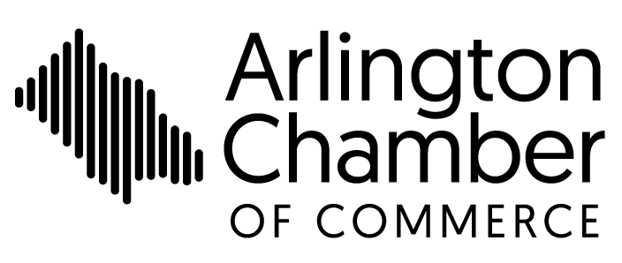

# Sponsorship Contract

This contract confirms your commitment to the sponsorship detailed below and confirms the amount owed to the Arlington Chamber for this sponsorship. For questions, please contact [Andrea Aiello, Membership](mailto:engagement@arlingtonchamber.org) Engagement Manager, at (703) 525-2400 or [engagement@arlingtonchamber.org.](mailto:engagement@arlingtonchamber.org)

Company

Authorized Representative

Address

City State _ Zip

Phone Email

I would like to secure the following sponsorship:

Name of Event

Sponsor Level

Instructions

Amount $

Payment: Please choose one of the following payment options

Invoice me

Check

Credit Card (Visa/Mastercard/American Express/Discover)

*Please make check payable to Arlington Chamber of Commerce*

Credit Card No. Exp. Date

Security Code Billing Zip Code

Signature Date

Please submit this form using one of the following forms of communication:

|  |  |
| --- | --- |
| Mail:  Arlington Chamber of Commerce  2009 14th St N, Suite 100  Arlington, VA 22201 | Email:  engagement@arlingtonchamber.org |